**DAILY ONLINE ACTIVITIES SUMMARY**

|  |  |  |  |  |  |  |  |  |
| --- | --- | --- | --- | --- | --- | --- | --- | --- |
| **Date:** | 12-06-2020 | | | | | **Name:** | Anvitha H M | |
| **Sem & Sec** | 4th ‘A’ | | | | | **USN:** | 4AL18CS010 | |
| **Online Test Summary** | | | | | | | | |
| **Subject** | | Aadalitha kannada. | | | | | | |
| **Max. Marks** | | 25 | | **Score** | | | 14 | |
| **Certification Course Summary** | | | | | | | | |
| **Course** | Front end development - CSS. | | | | | | | |
| **Certificate Provider** | | | Great learning academy | | **Duration** | | | 8 hours |
| **Coding Challenges** | | | | | | | | |
| **Problem Statement:** Java program to remove all the tens in an array. | | | | | | | | |
| **Status:** Executed | | | | | | | | |
| **Uploaded the report in Github** | | | | | YES | | | |
| **If yes Repository name** | | | | | <https://github.com/alvas-education-foundation/Anvitha-H-M> | | | |
| **Uploaded the report in slack** | | | | | Yes | | | |

**Online test:**

It was from all the chapters and the test was for 25 minutes having 25 question all multiple choice question. The questions were simple and optimal and the score that I got was 14/25.

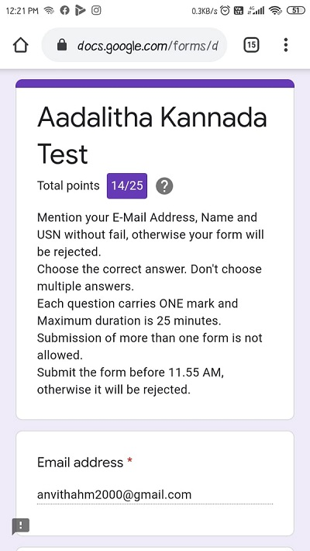

**Certification course:**

Front end development - CSS

The course includes detailed explanation preference order structure, pseudo class, nth of type selector and types of combinator used in CSS like ascendant, descendant, parent-child and no space with exercising quiz.

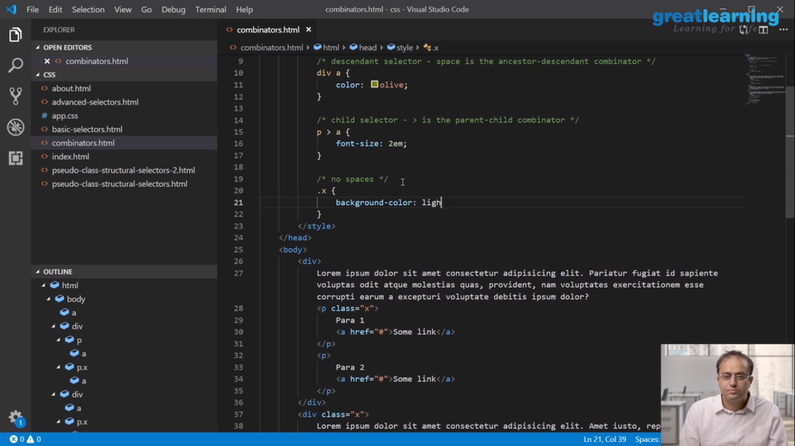

Online coding challenge

The programing statement of the day is

“Program in Java to remove all the tens in an array.”

Solution: Executed and uploaded in Github repository.

Link: <https://github.com/alvas-education-foundation/Anvitha-H-M>

